Goals:

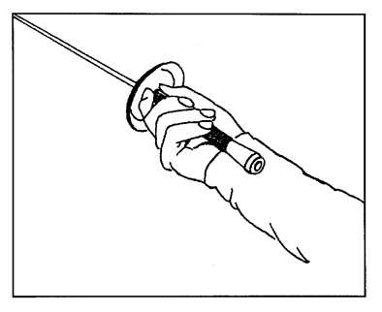

1. The Grip

A) Holding the weapon.

1. Correct positioning of thumb and index finger.

2. Pommel remains parallel to the axis of the hand.

3. A hole is formed between the thumb, index finger and handle.
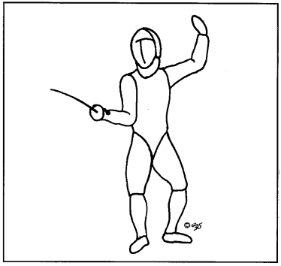

2. The On Guard Position.
A) En Guard
- The feet should be positioned at a 90 degree angle.

- The heels should be on a single straight line.

- The fencer has to bend his knees in such a way so that a straight line from the knee of the leg to the toes of the foot can be drawn.

- There should be around 1.5 feet distance between the front and back foot.

- The centre of gravity is in the middle, weight distributed equally between both feet.

- The body is turned sideways, back is straight and shoulders are relaxed.

- The forearm should be straight and parallel to the ground, elbow does not protrude.

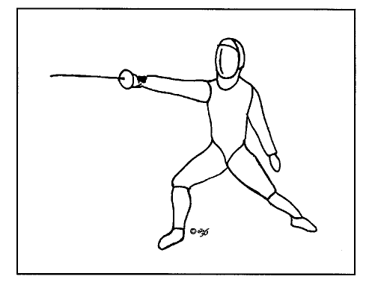

3. The Lunge
A) Lunge

1. Extend the arm before beginning the lunge, without any extraneous shoulder movement.

2. Front foot kicks, ball of the foot leaving the ground first.

3. Back foot extends, providing power to the lunge.

4. Back foot remains rigorously flat and knee extended.

5. Front foot lands heel first, knee above heel at an angle of 90 degrees.

6. Back is straight, back arm and front arm extended forming a straight line.

B) Step Lunge

1. Small slow step during which the arm is extended and the reaction of the opponent is observed, swiftly followed by a lunge.

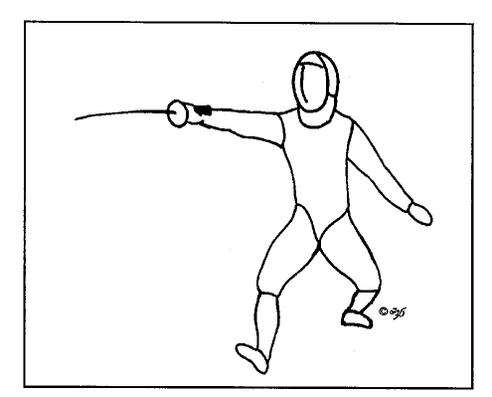
2. Small fast step during which the arm is extended and swiftly followed by a lunge.

4. The return to Guard
A) Backwards

1. The rear leg rapidly bends, the torso rises the hips move backwards.

2. The non weapon arm and the weapon arm retract as one returns on guard, but not sooner.

B) Forwards

1. The back foot is moved forward, the torso returns to a vertical position, the non weapon arm is retracted while the weapon arm remains extended.

C) Backwards Jump

1. The rear leg rapidly bends, the torso rises the hips move backwards.

2. The front exerts a strong push on the floor, propelling the fencer backwards. The back leg remains extends a little but remains mostly flexed.

3. The fencer lands in En Guard position, with a distance of a backwards en guard + 1 extra step.
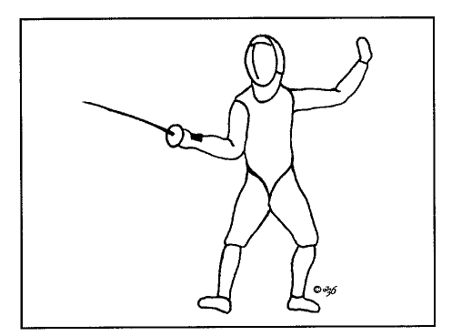

5. Footwork

A) Step forwards

1. Lift the ball of the front foot. Move the front foot forward landing heel first and immediately move the back foot forward as well. Make sure that the distance between the feet remains the same, the front foot makes a small step followed by the back foot making a step of the same size.

B) Step backwards

1. Move the backwards leg the appropriate distance, immediately push from the front leg and bring it back.

C) Jump forwards

1. Kick with the front leg as if you were to do a lunge, at the same time push from the back leg propelling the body forwards. Bring the front leg back into a flexed position and land with both legs touching the ground simultaneously.

D) Jump backwards

1. Lift the bent rear leg, push from the front leg with extension to propel backwards. Bring the front leg back into a flexed position and land with both legs touching the ground simultaneously.

6. Invitation

7. Simple attack

8. Simple parry

9. Ripostes and counter ripostes

10. Feints and compound attacks

11. The beat

12. The counter attack

13. The remise

14. The reprise

* 10 Marks.

Mark 1 is awarded on first day of learning the new technique.

Mark 2 – 4 awarded when the fencer actively uses and attempts to correct his technique whether in exercise or bouts.

Marks 5 – 7 awarded when the fencer actively uses and attempts to correct his technique only in bouts.

Marks 8 and 9 awarded when the fencer shows exemplary technique and the coach does not need to correct him.

Mark 10 is awarded when the technique is successfully used in a competition.

Maximum of 1 mark per category per week.

